**Q1 HAWT**

What are the components in a HAWT type wind turbine system? Describe the function of each component.

blade pitch system: convert the kinetic energy from the wind into rotating shaft power, achieve the highest rotor efficiency, and protect the turbine from strong wind

Yaw system: Aligns the turbine with the wind to maximize energy

capture and efficiency.

Gearbox: Increases the rotational speed to a higher speed suitable for the generator.

Generator: Converts the mechanical energy of the rotating shaft into electrical energy for use or distribution. (from AI)

**Q2 blades twisted 为什么叶片旋转**

Why are wind turbine rotor blades twisted towards the end?

--For a constant rotational speed, the speed of the rotor along the blade is proportional to the distance the hub. The nearer to the tip, the stronger the apparent wind is. So, blade must be twisted to keep the angles right to maximize the lift-to-force ratio.

**Q3 简单算功率**

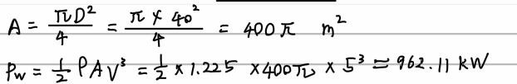What is the specific power in wind at a location with wind speed of 5m/s? Determine the theoretical maximum power output of a 40-m diameter wind turbine generator at this location. Assume density of air to be 1.225Kg/m3.

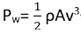Ex. Power int the wind depends on, -Air density, -Area the wind flow through and -Wind speed

Power vs Swept Area: A=π/4*D2(HAWT)The larger the rotor, the more energy it can capture. The larger the diameter of its blades, the more power it is capable of extracting from the wind.

Power vs Diameter: A=2/3DH(VAWT), Increase in diameter causes only a linear increase in the power available. (while In HAWT doubling the diameter increases the power available by a factor of 4.)

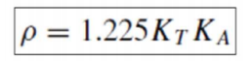Power vs Air Density: ρ=P/RT

**Q4 先算风速再功率**

The wind speed in a city area is 5 m/s at a height of 10m. The location has a friction coefficient of 0.4. What is the specific power at a height of 50m? Assume density of air to be 1.225Kg/m3.

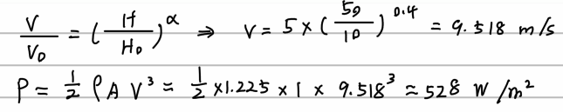

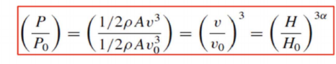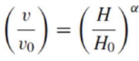**Impact of Tower Height**: One way to get more power output from a wind system is to increase the height to which the height to which the blades are exposed. (The reason is wind speed can be seen as a function of height and earth’s surface.)

**=>Ex高度比算风力**

A wind turbine with a 30-m rotor diameter is mounted with its hub at 50 m above a ground surface that is characterized by shrubs and hedges. Estimate the ratio of specific power in the wind at the highest point that a rotor blade tip reaches to the lowest point that it falls to.

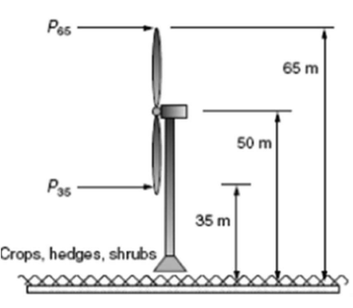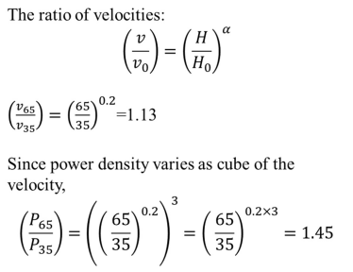

**Ex/Q.11 Power Extracted 理论最大功率**

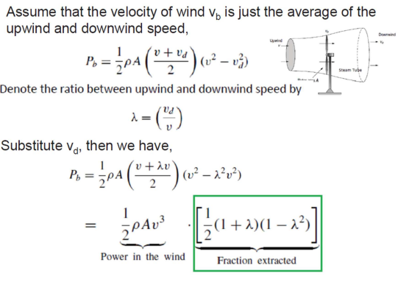**From first principle, derive Betz’s Law for retrieving maximum energy from wind using a wind turbine**

named as Rotor Efficiency (CP)

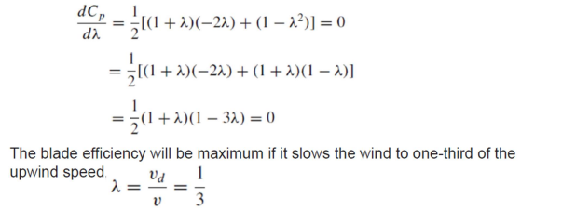

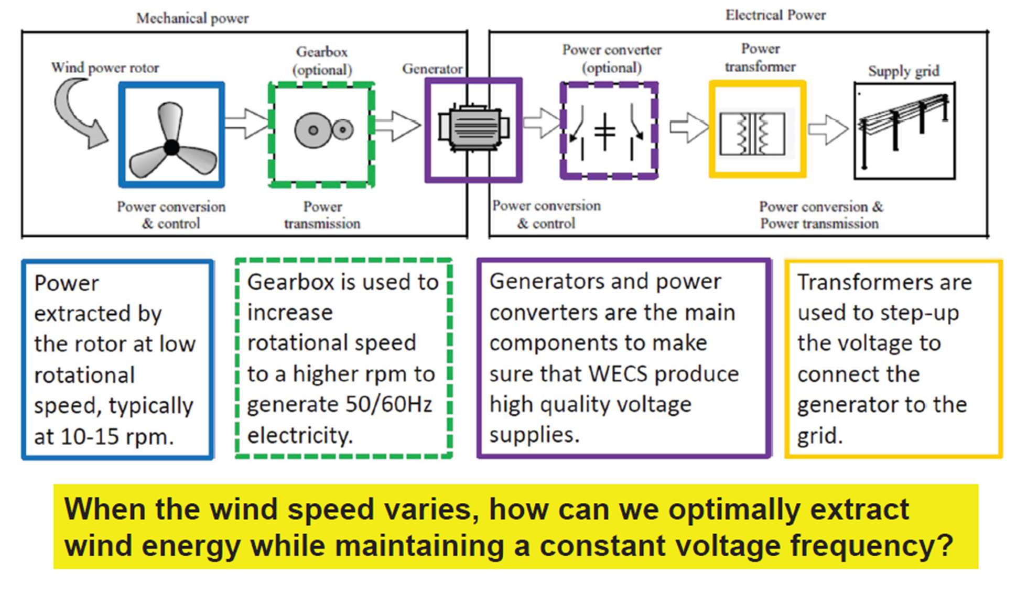

substituting 1/3 => the maximum theoretical efficiency of the rotor is **59.3%** (Betz efficiency). modern wind turbine to this limit: around 80% of this limit 40-50%

**Q.5/Q12 TSR算RPM**

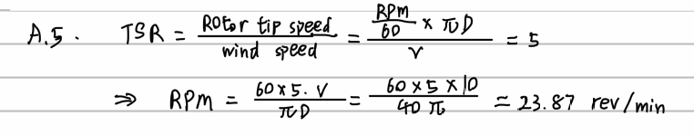At tip-speed-ratio of 5, what is the rpm of the wind turbine rotor with a diameter of 40m, if the wind speed is 10m/s?

**Q12TSR** What is the tip seed ratio (TSR) of wind turbine? How does TSR affect the rotor efficiency of a wind turbine?

--For a given wind speed, the rotor efficiency depends on the speed of rotation of the blades. TSR is the speed at rotor tip divided by the wind speed. =>

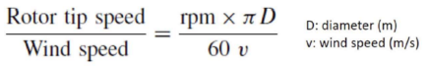

If TSR is high, it means that the blade spins too fast, and that the blade will experience turbulent wind.

If TSR is low, it means that the blade spins too slowly, and it cannot efficiently capture wind energy.

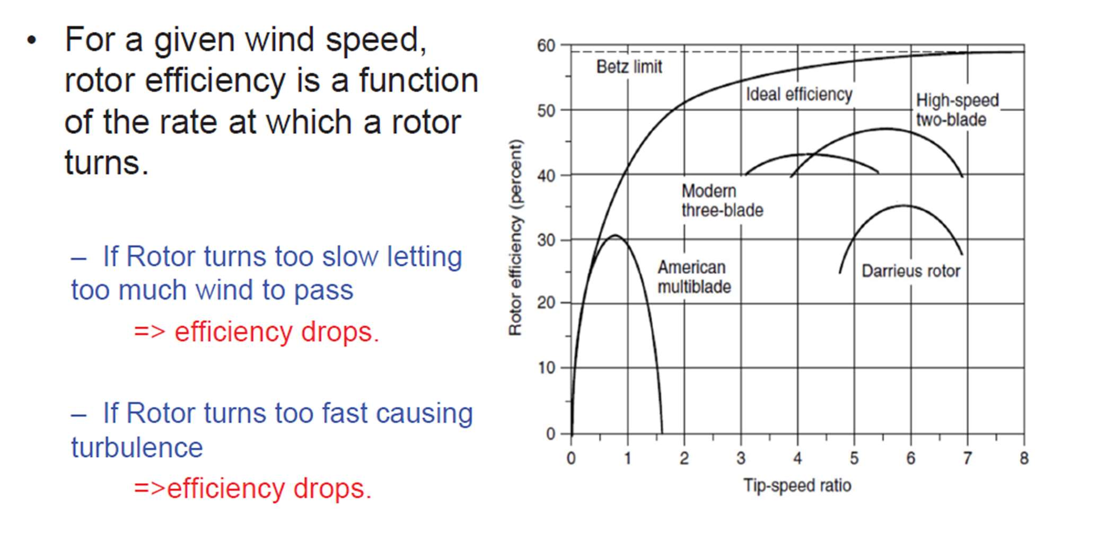The optimal TSR gives the maximum efficiency that a turbine can extract wind energy.

**Ex. rpm、tip speed、gear ratio、efficiency of complete system**

A 40-m, three-bladed wind turbine produces 600 kW at a wind speed of 14 m/s. Air density is the standard 1.225 kg/m3. Under these conditions,

a. At what rpm does the rotor turn when it operates with a TSR of4.0?

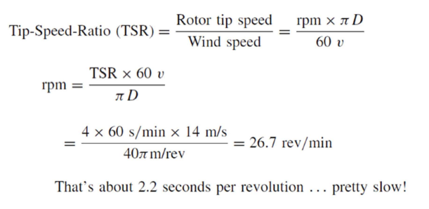

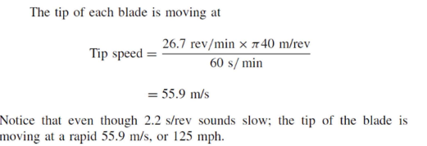b. What is the tip-speed of the rotor?

c. If the generator needs to turn at 1800 rpm, what gear ratio is needed to match the rotor speed to the generator speed?

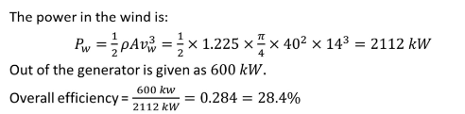d. What is the efficiency of the complete wind turbine (blades, gear box, generator) under these conditions?

**Q.6 required thrust to rotate**

Explain how the rotor blades in a wind turbine get the required thrust to rotate.

--Air moving over top of airfoil has more distance to travel→ Air pressure on top is lower than under airfoil→ “Lift” is created

**Q.7 转速控制**

What are the various methods used for varying the wind turbine rotor speed based on wind speed?

1.Turbine speed control

-Goal: To achieve highest rotor efficiency i.e. to operate at optimal TSR; To protect the turbine from strong winds

-How: Adjust angle of attack at the turbine blades; Stall or pitch control

2.Generator speed control

-Goal: To maintain constant frequency of the voltage output

-How: Multiple gearboxes design for different rotor speed to generator speed ratios; Different generator designs and power converters are used to adjust the voltage frequency to be the same at the grid frequency

**Q.9大风扇为什么经济效益高**

Using appropriate equations, explain why it is economical to increase the size of the wind turbine rotor.

A=π/4*D2(HAWT), doubling the diameter increases the power available by a factor of 4.

The cost of a turbine increases roughly in proportion to blade diameter, but power is proportional to diameter squared, SO bigger machines have proven to be more cost effective

**Q.8 wind energy conversion system（图在上一栏）**

Draw the complete block diagram of the wind energy conversion system to convert wind energy to electricity for the grid. Briefly explain the function of each block.

**Q.10大型风力涡轮机机的应力**

Explain the cause of rotor stress in large wind turbines.

--The blade at the top of its rotation can experience much higher wind speeds than at the bottom of its rotation. This results in flexing of the blade.

**Q.13 各种类型的风力涡轮机，**Describe the various types of wind turbine generators based on type of speed control used.

Wind turbine generators can be divided into 5 types.

1. Type 1: Fixed speed (1-2% variation) Use aerodynamic to control turbine blades by stall or pitch control.

2. Type 2: Limited variable speed (10% variation) 3. Type 3: Variable speed with partial power electronic conversion (30% variation) 4. Type 4: Variable speed with full power electronic conversion (full variation) (Decouple the electrical grid frequency and mechanical rotor frequency using power electronics systems to interface the grid)

5. Type 5: Variable speed with mechanical torque converter to control synchronous speed (full variation) (Mechanical control)

**Q.14 不同种发电机以及电气速度控制**

Using block diagram, describe the various types of variable speed wind turbine generator systems with electrical control on generator side.

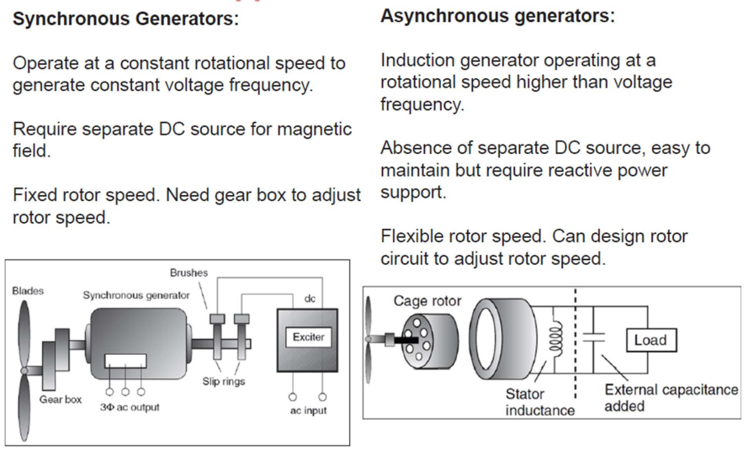

**Q.15 DFIG双馈感应发电机**

Using block diagram, explain the operation of wind turbine system with a doubly fed induction generator (DFIG).

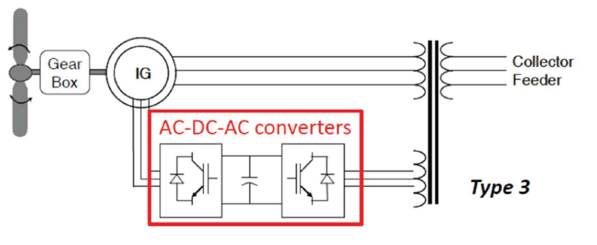

• Instead of variable resistors in Type 2, this Type 3 design adds AC-DC-AC converters to the rotor circuit.

• Rotor frequency is decoupled from grid frequency.

• The machine can still be synchronized with the grid while the wind speed varies.

**Q.16 type 4**

Using block diagram, explain the operation of variable turbine speed, type 4 wind turbine system with a Synchronous generator.

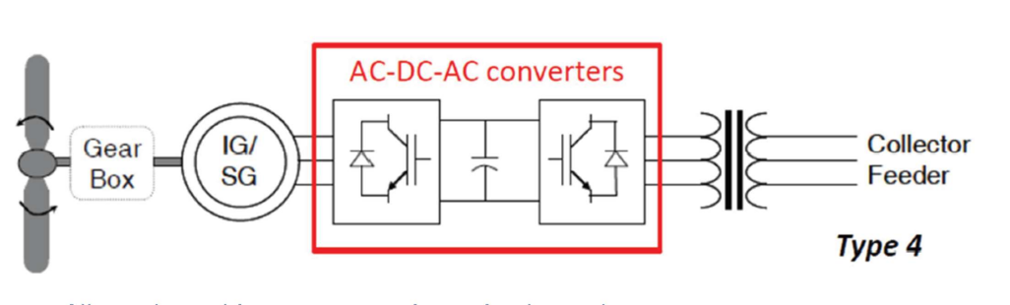

• Allows the turbine to rotate at its optimal speed.

•AC output from generator frequency is different and decoupled from grid frequency.

•AC-DC-AC converter is used to connect the AC output to the grid.

•Full control and flexibility in the design and operation of wind turbine.

•The ratings of power electronics are higher than Type 3.

**Q.18 wind shedding**

What is meant by wind shedding? Explain the various methods for shedding wind power?

--Rated wind speed, start to shed some of wind power. Wind turbine stop operating to protect the machine.

--How to Shed Wind Power

•Pitch-controlled turbines– Active control by reducing ‘angle of attack’

•Stall-controlled turbines– Passive control using pure aerodynamic design.

•Active stall control– Induce stall for large wind turbine by increasing ‘angle of attack’.

•Passive yaw control– Small kW size turbine, causing axis of turbine to move off the wind.

**Q.17 理想输送功率与风速曲线**

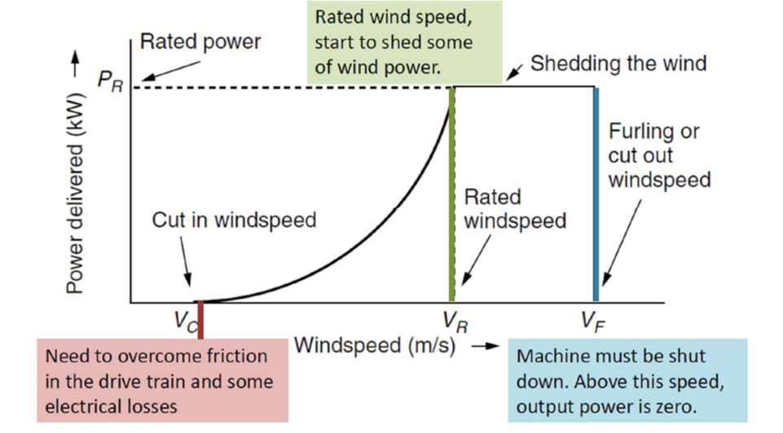Draw the ideal power delivered vs wind speed curve for a wind turbine generator. Clearly explain the operation at different wind speed

**Q.19 计算一天的总发电量(带有cut-in cut-on)**

The table below gives the measurement of wind speed during one day. Calculate the total energy generated for the day using a 40-m diameter rotor wind turbine generator with rotor efficiency of 40% and generator efficiency of 85%. The cut-in speed is 3 m/s and cut-out speed is 9 m/s. Assume there is no wind shedding.

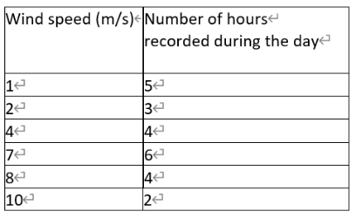

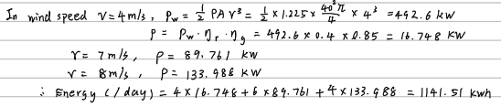

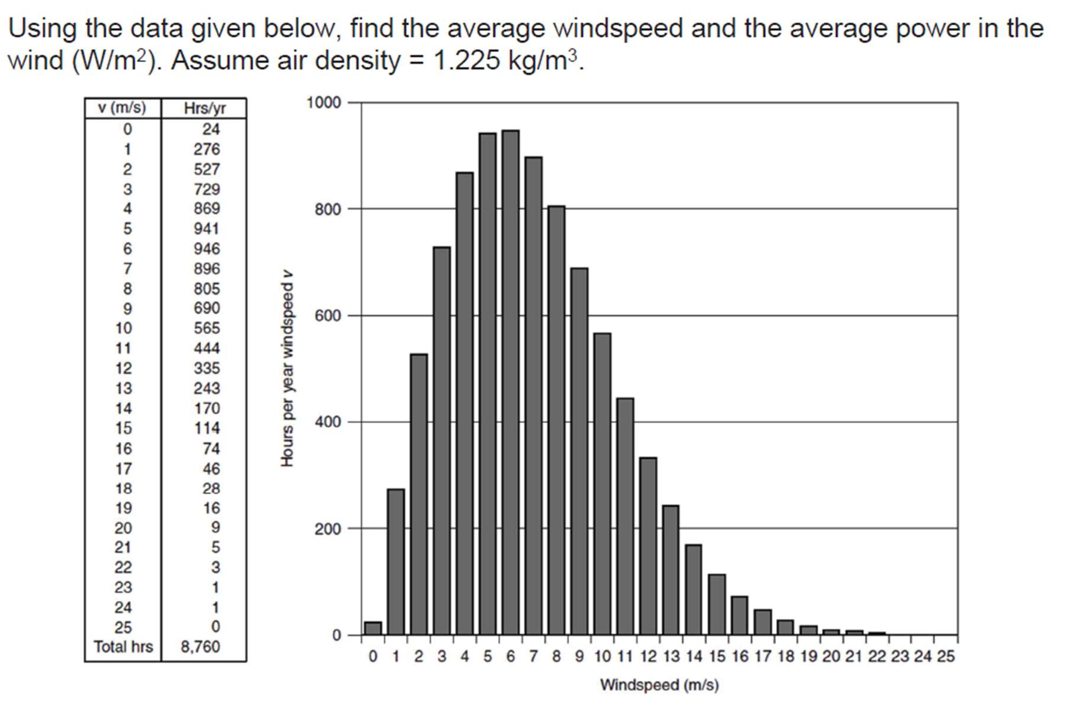**Ex3 计算一年的总发电量**

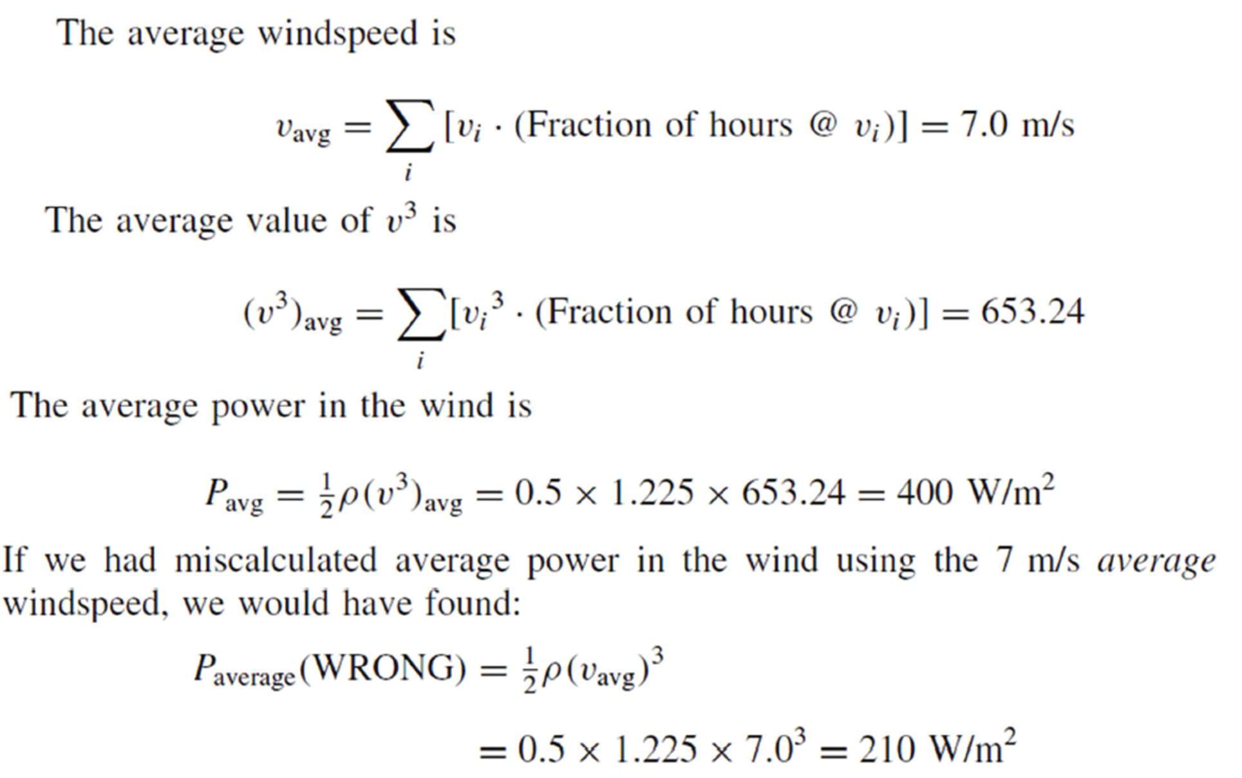

以下全为作业未涉及内容

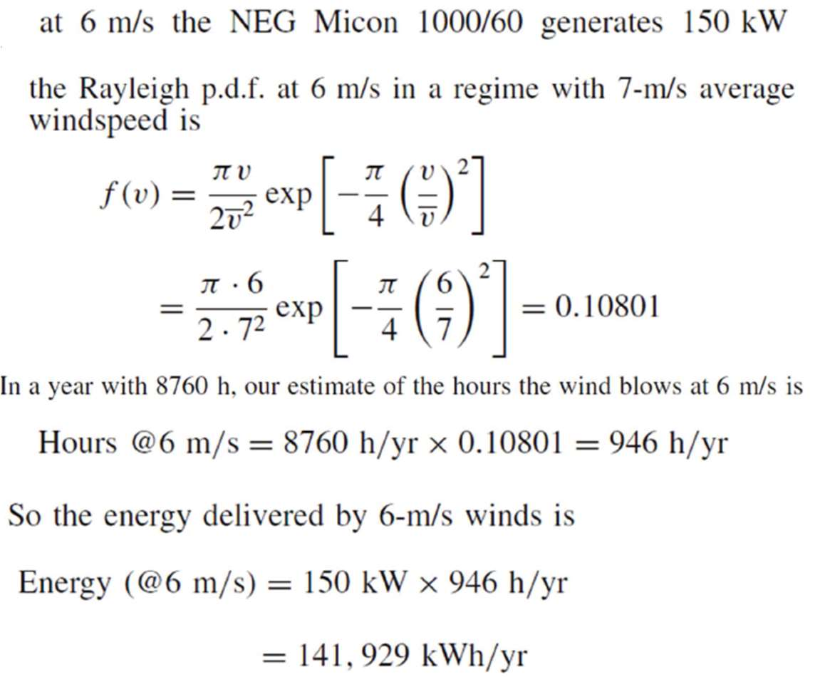**Ex4.瑞利分布风速Rayleigh PDF: Average Power**

瑞利分布的风速下，给定平均风速可以直接用下面公式计算平均功率

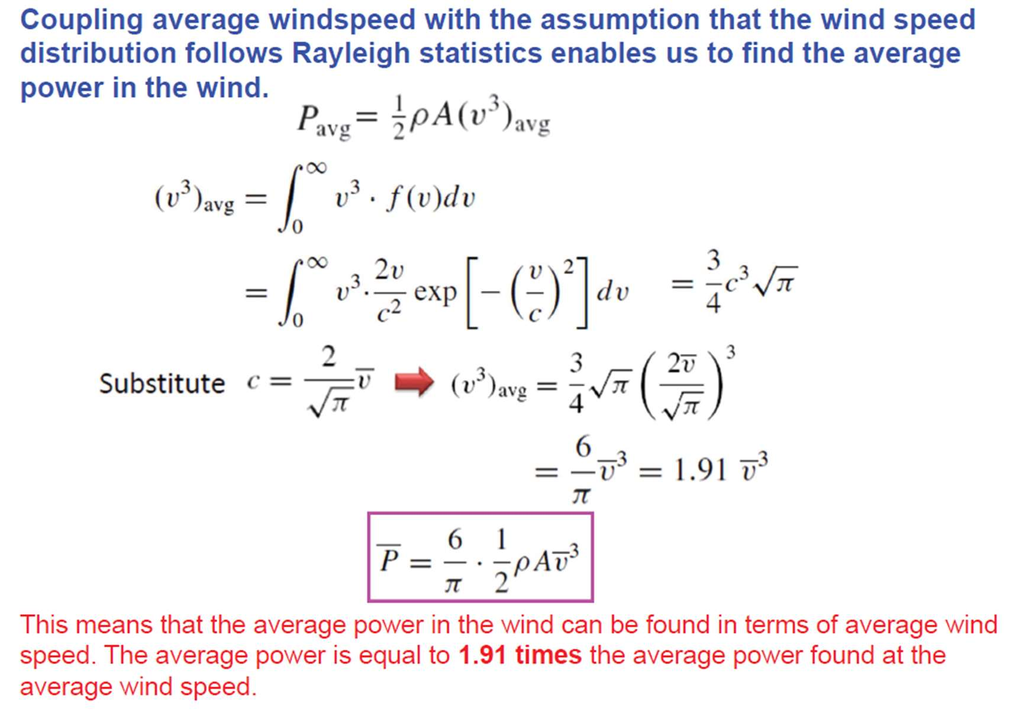

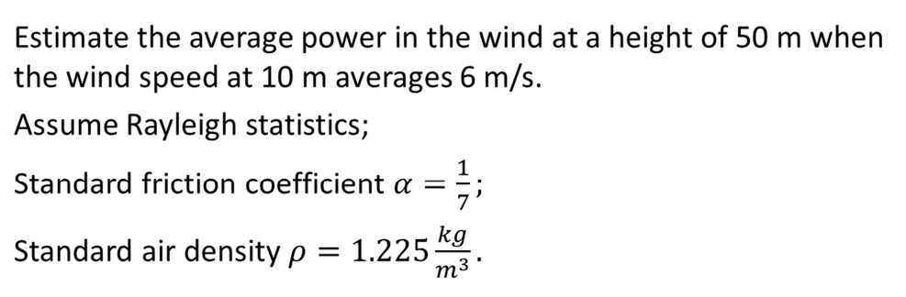

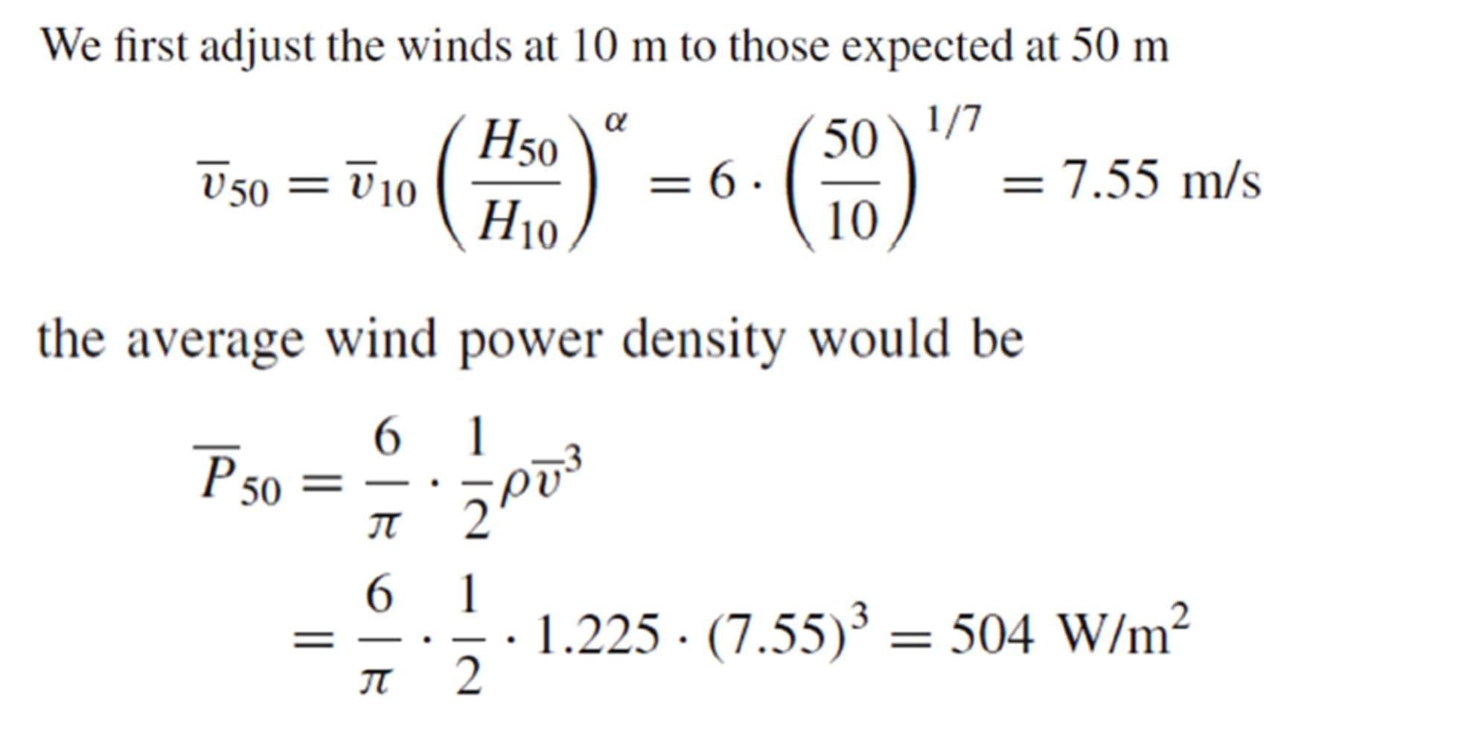

**Ex5 Energy Estimate of Wind Farms 风电场能量估算**

• Large number of wind turbines.

• Clustered together at the same windy site.

• Centralized operation and maintenance, reducing cost.

Spacing between wind turbines needs to be properly designed.

• To optimally capture wind energy.

• To reduce ‘wake effect’.(The 'wake effect' is the trail left by each turbine where wind speeds are reduced. The wind regime generates additional turbulence to that already produced by the terrain, affecting nearby wind turbines and even neighboring wind farms.)

Tower Spacing Study

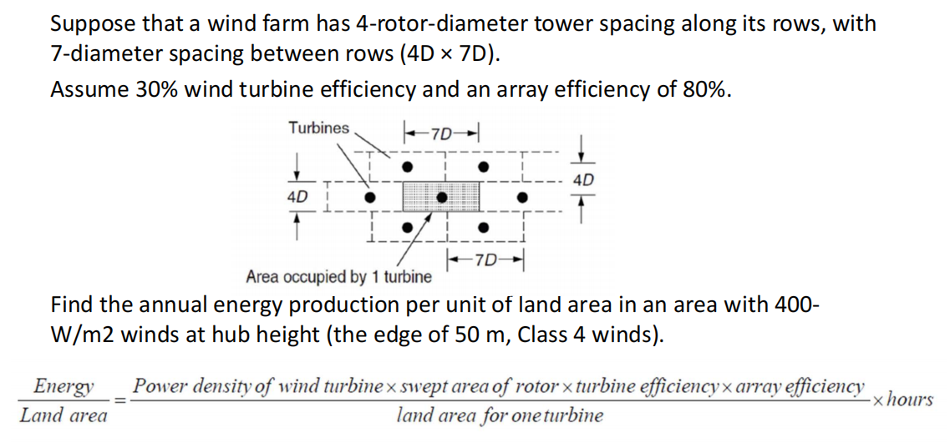

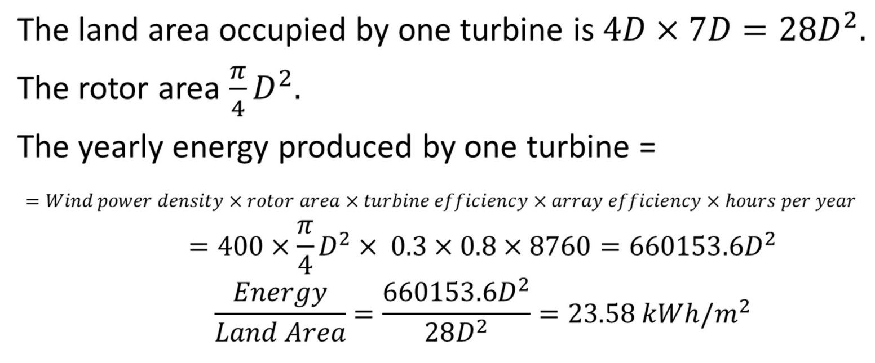

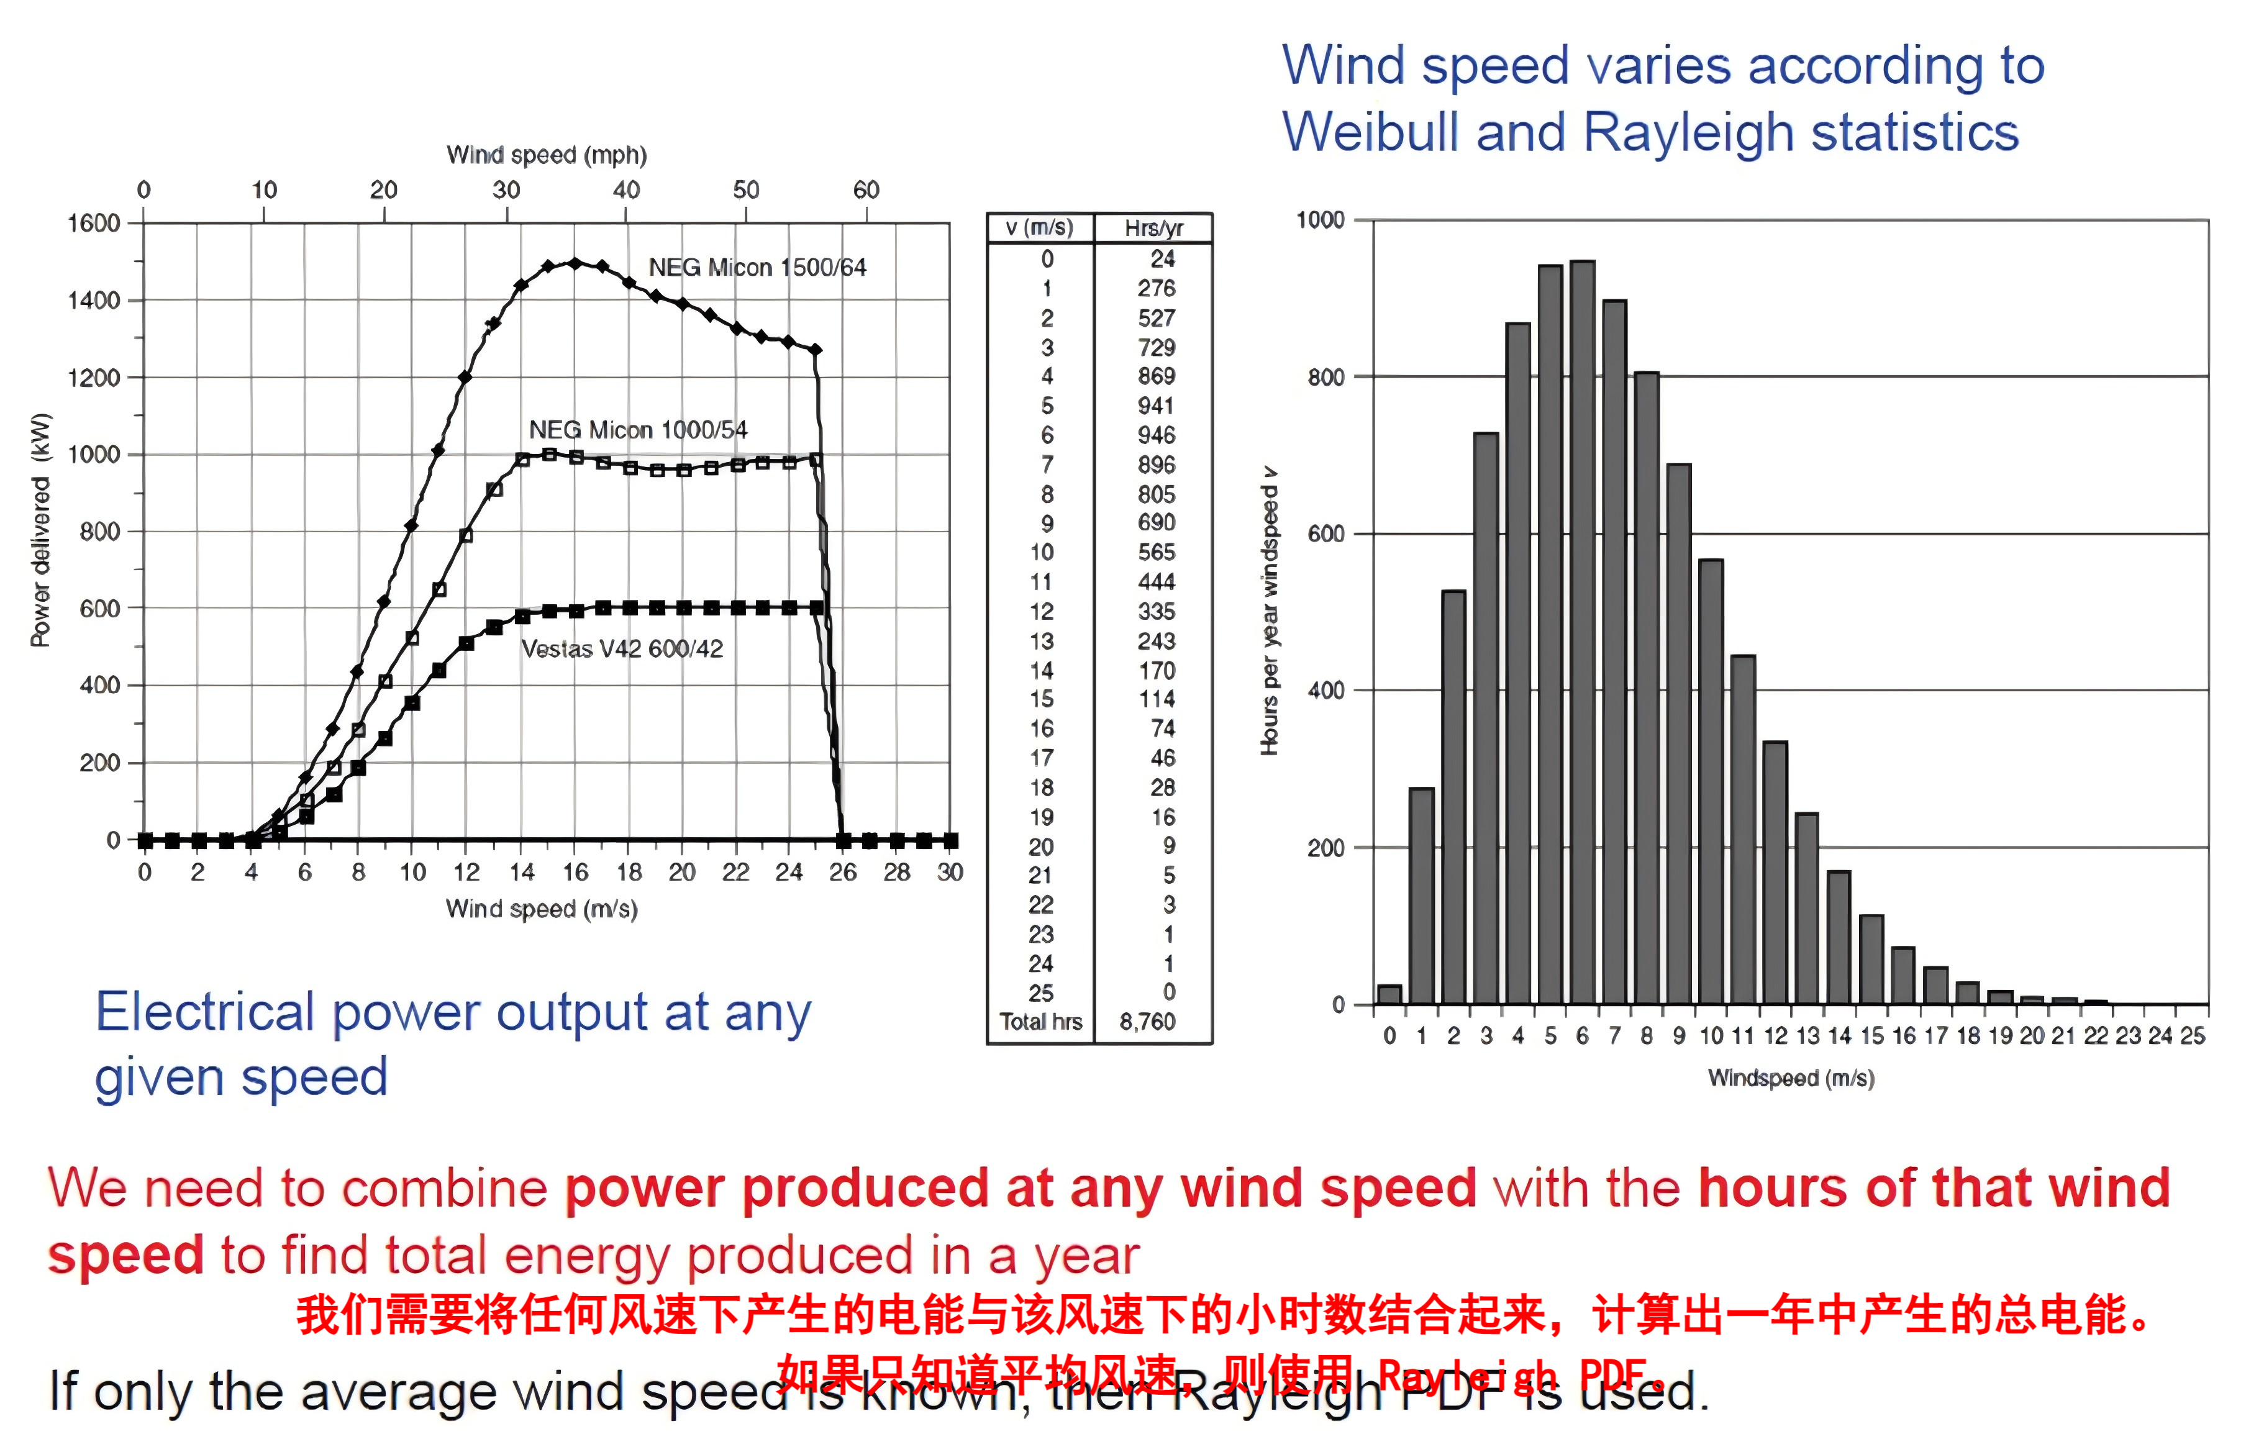**Ex.6 Annual Energy Production: Spreadsheet Method**

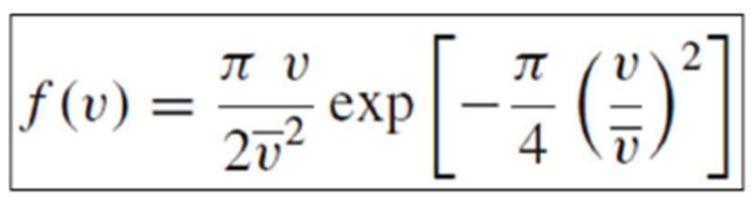

给定平均风速下，可以列出风速的瑞利型概率密度函数，从而知道每个风速的小时数。

Suppose that a NEG Micon 60-m diameter wind turbine having a rated power of 1000 kW is installed at a site having Rayleigh wind

statistics with an average wind speed of 7m/s at the hub height. The generator output for various wind speeds are given on the right.

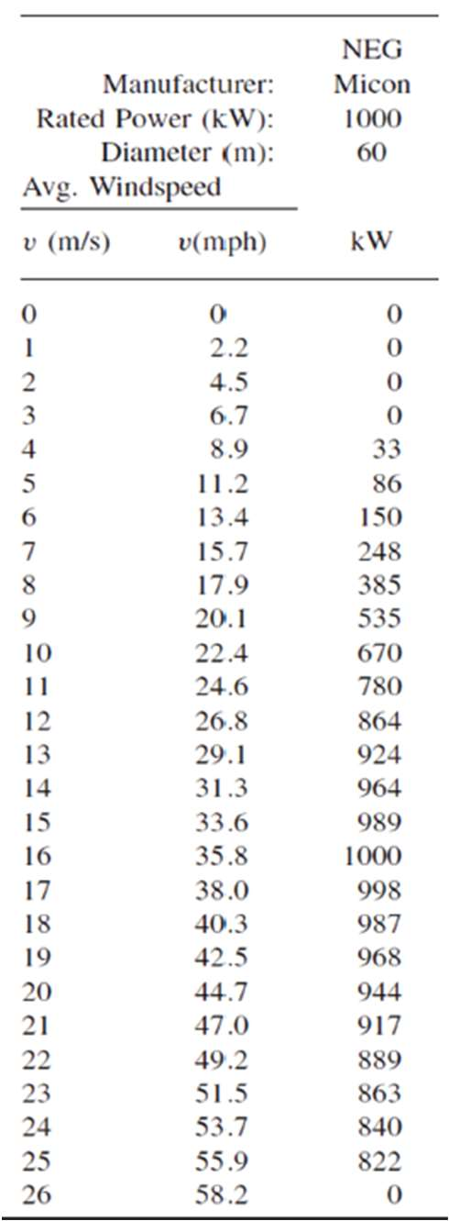a) Find the annual energy generated.

b) From the result, find the overall average

efficiency of this turbine in these winds.

c) Find the productivity in terms of kWh/yr

delivered per m² of swept area.

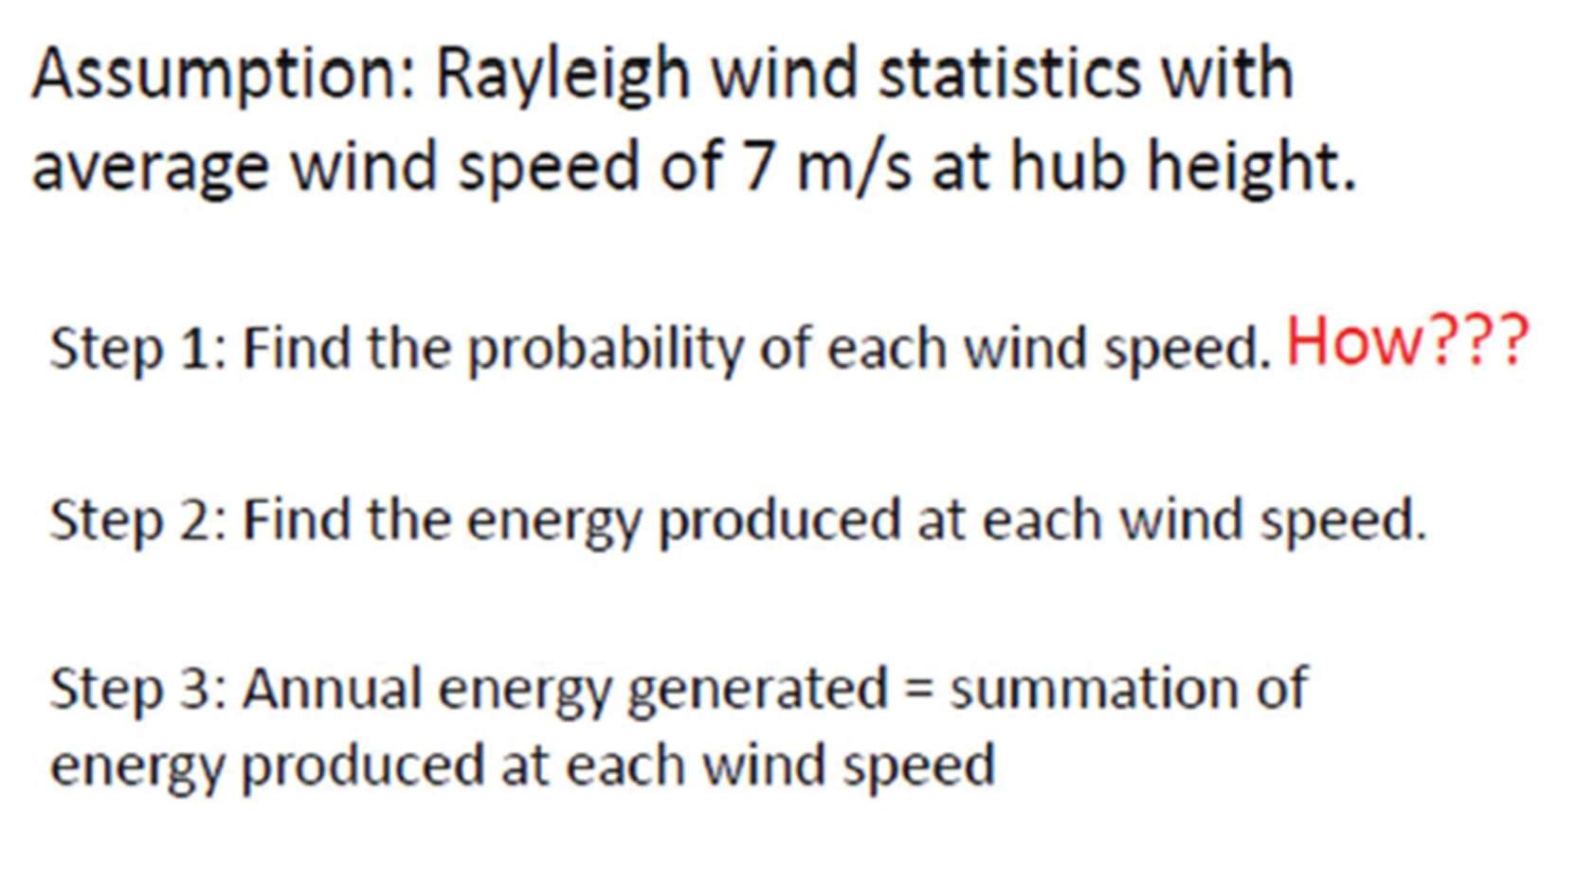



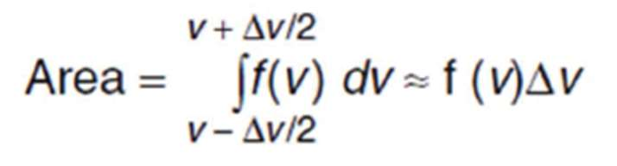

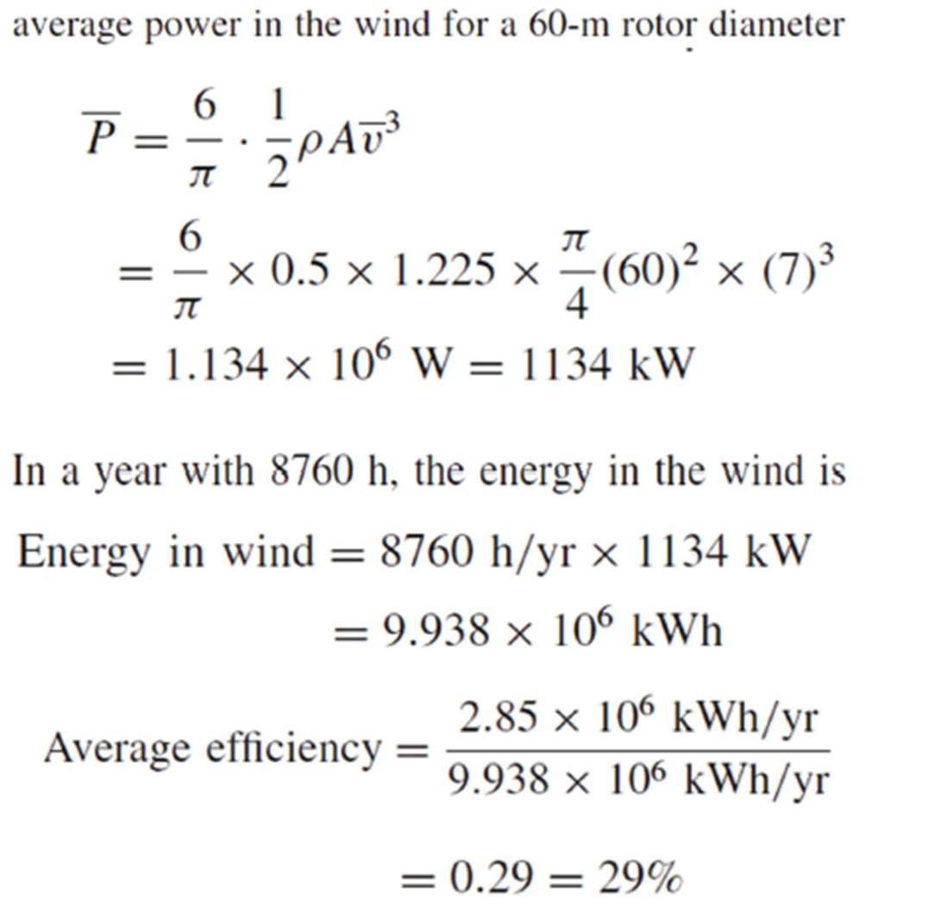

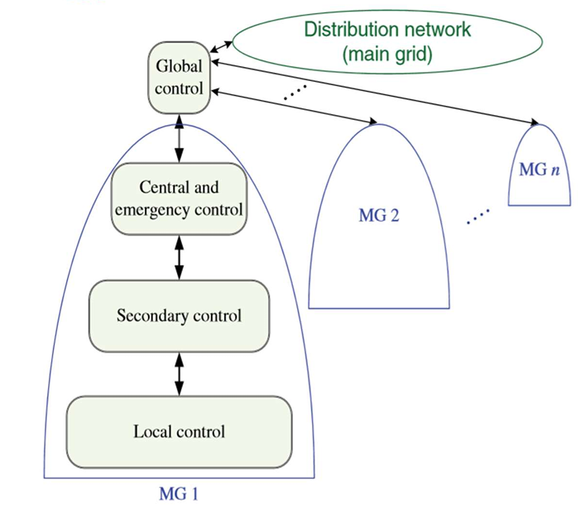

**Ex.7 Capacity factor 风力发电机的CF**

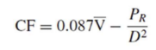

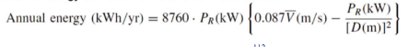

The Whisper H900 wind turbine has a 900-W generator with 2.13-m blades. In an area with 6-m/s average wind speed, estimate the approximated energy delivered.

Capacity factor is a measure of the fraction of actual energy delivered to the rated energy output in one year.

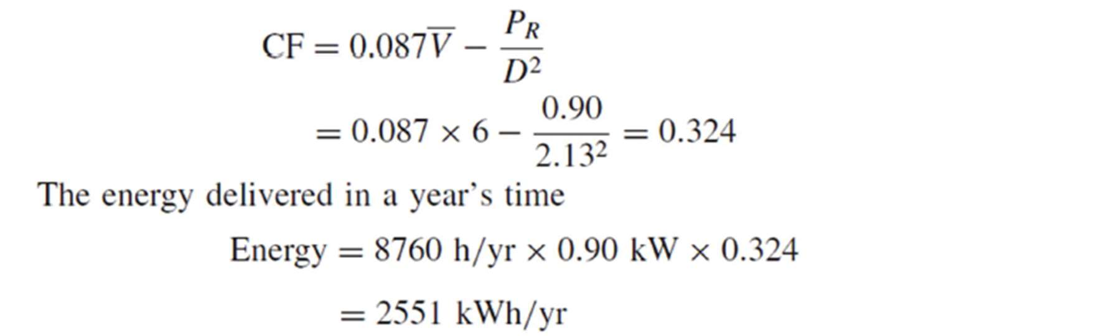

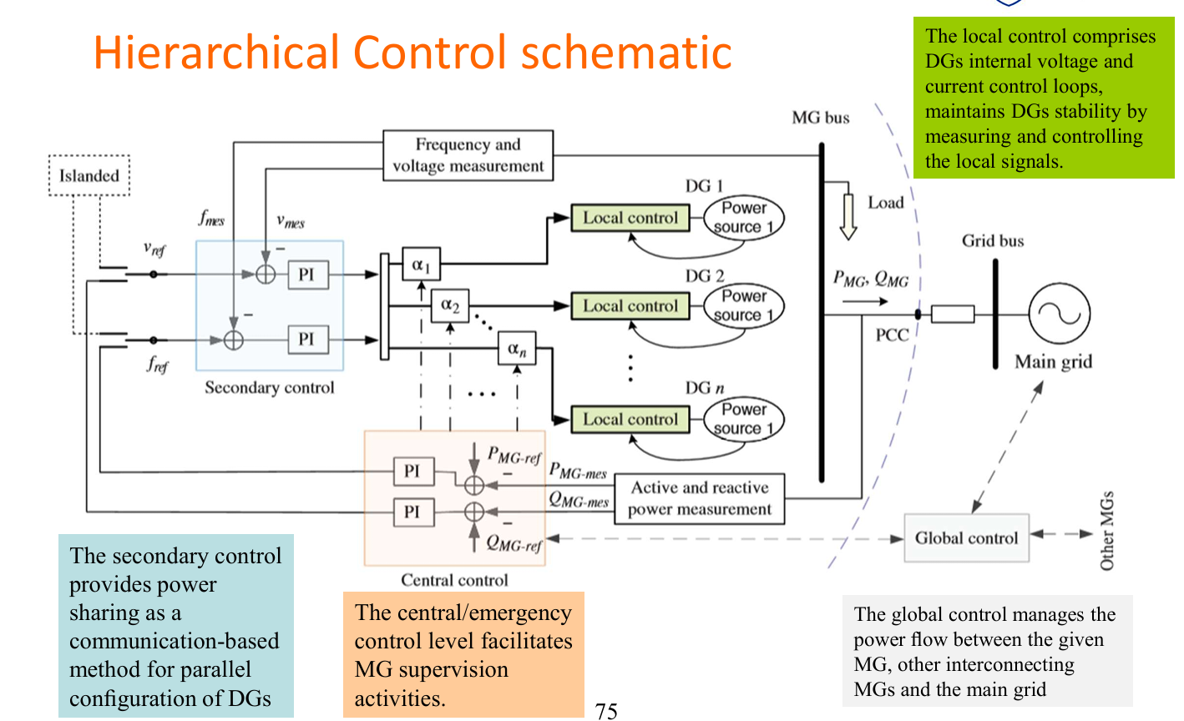

补充：PV的CF

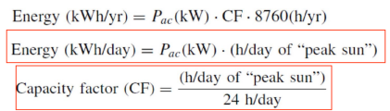

Virtual Synchronous Generators : Dynamic Performance and Characteristics

• Asolution towards stabilizing a grid/MG with numerous low-inertia DGs is to fortify the system with additional inertia, virtually. • Virtual inertia can be established by using short-term energy storage together with a power electronics inverter/converter and a proper control mechanism in a system that is called virtual synchronous generator(VSG).

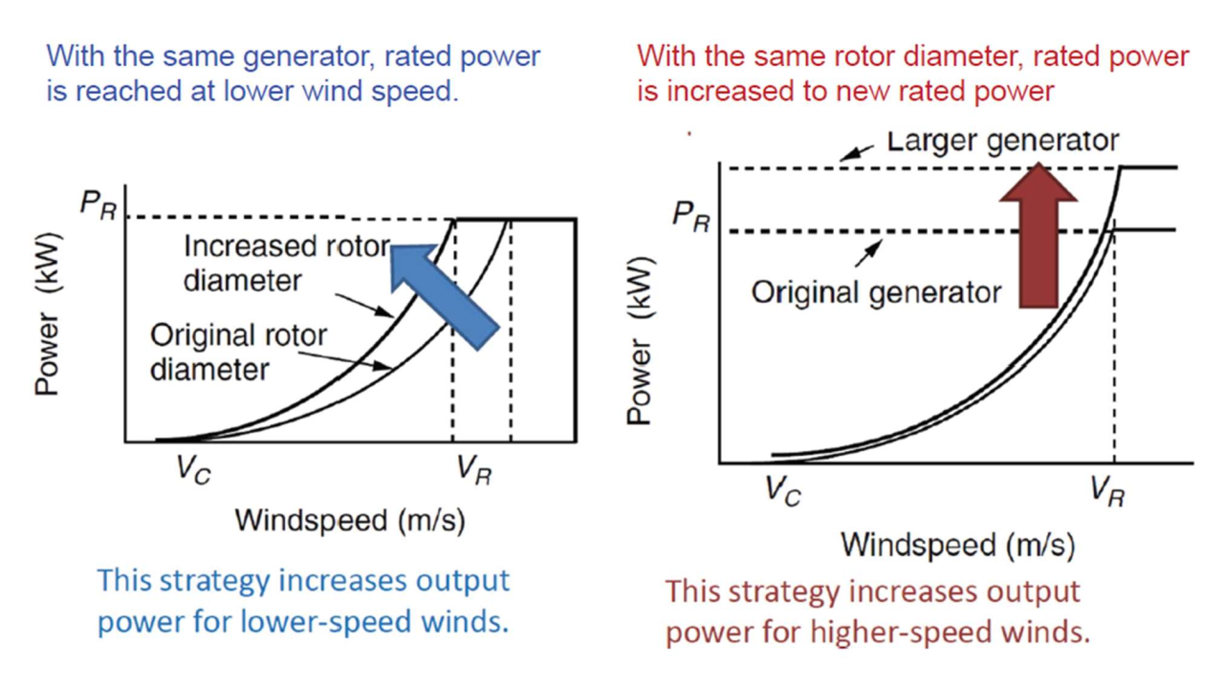Ex.8

**Micro Gird**

Micro grids comprise LV distribution systems with distributed energy resources (DER) together with storage devices (flywheels, energy capacitors and batteries) and flexible loads.non-autonomous way (if interconnected to the grid) or in an autonomous way, if disconnected

Microgrid is an integration platform for supply-side (microgeneration), storage units and demand resources (controllable loads) located in a local distribution grid. both normal state (grid connected) and emergency state (islanded) operation

Importance of Storage System: During renewable excess/deficit, During Islanded mode, To flatten load curve

Storage technology options and modes:

• Potential energy (pumped hydro, compressed air, springs) • Kinetic energy (mechanical flywheels) • Thermal energy without phase change • Thermal energy with phase change (ice, molten salts, steam) • Electrochemical energy (batteries, flow cells) • Electrostatic energy (capacitors) • Electromagnetic energy (superconducting magnets)

Pumped Hydro System: • Water is pumped from a lower reservoir uphill and then allowing it to f low downhill to through turbines to produce electricity. • Readily available and widely used in high power applications • Lower cost of power, frequency regulation on the grid, and reserve capability • Can only be implemented in areas with hills

Flywheels:A cylinder that spins at a very high speed, storing kinetic energy

Compressed Air Energy Storage (CAES): • Utilities use electricity generated during off-peak hours (i.e., storage hours) to compress air and store it in airtight underground caverns. • When the air is released from storage, it expands through a combustion turbine to create electricity.

**DC Micro grid**

Importance of DC: • Various conversion stages like AC-DC/DC-AC can be avoided by forming DC Grid and Overall System efficiency can be improved. • No problem of reactive power, harmonics, frequency control. • No synchronization issues and Controlling becomes easier. • Eddy current, hysteresis losses and skin effect are absent. • Reduces stress on conventionally grid, congestion of transmission line will be reduced.

DC Microgrid Topologies: Single Bus Topology

• ESS directly connected to DC bus Suitable for low voltage applications likely 48V. • ESS Connected with converter More flexible control and also improves reliability of the system

Multi-bus DC Microgrid Topology, DC ring bus architecture, Zonal configuration, Multi-terminal DC system

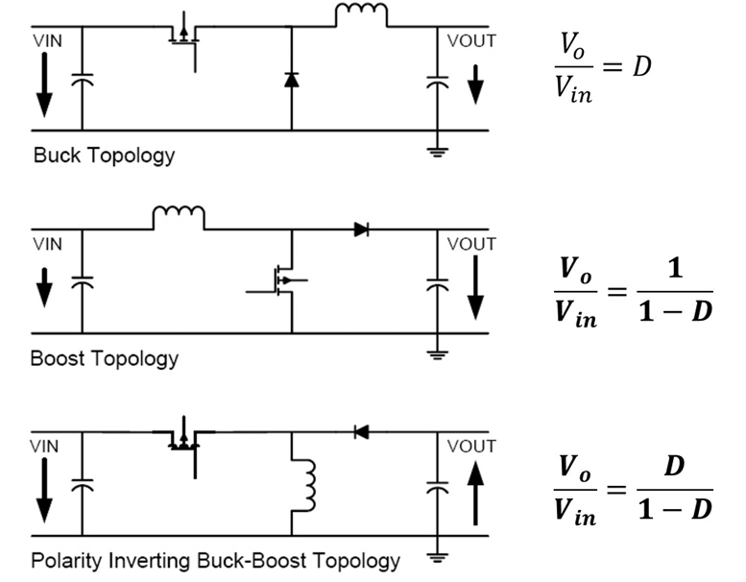Classic DC-DC converter topologies

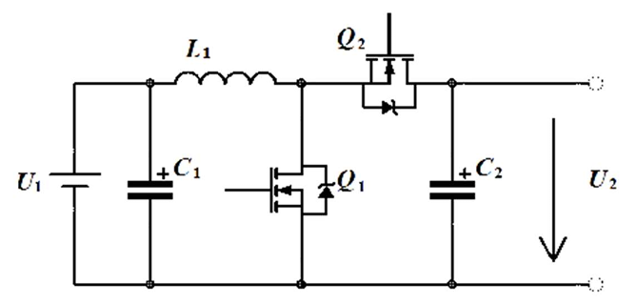

Bi-Directional DC-DC converters

• Single converter • Simplicity using minimal storage elements. • Allow bi-directional power flow from one source to other and vice versa

**Microgrid Control**

• Inconventional power grids, stability analysis is well established with standard models of synchronous generators, governors, and excitation systems of varying orders that are known to capture the important modes for particular classes of problems. • This does not yet exist for the MGs and may be difficult to achieve because of the wide range of power technologies that might be deployed. • New high-level control strategies and management rules are required to ensure system reliability. • Current, voltage/amplitude, frequency /angle, and active and reactive power are the main feedback variables used in the existing MG control loops in both grid-connected and islanded operation modes. • The MG control is responsible for providing proper load sharing and DG coordination, voltage/frequency regulation in both operating modes, MG resynchronization with the main grid, operating cost optimization, and power flow control between the MG, neighborhood grids, and the main grid. • MGs should be able to not only operate autonomously but also interact with the main grid. • In the grid-connected operation mode, the MGs are integrated into a constantly varying electrical grid with changing tie-line f low, voltages, and frequency. To cope with those variations, to respond to grid disturbances, and to perform active power/frequency regulation, as well as reactive power/voltage regulation, MGs need to use proper control loops. • Furthermore, suitable islanding detection feedbacks/algorithms are needed to ensure a smooth transition from the grid connected to islanded mode to avoid cascaded failures

Hierarchical Control: Consists of four levels: 1. local (primary) controls2. secondary controls3. central/emergency controls4. global controls

